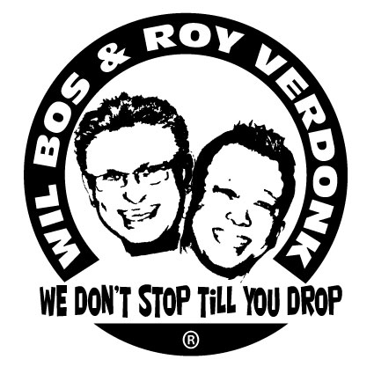
Don’t Need A Doctor, JUST A CURE

Choreographers : Wil Bos & Roy Verdonk

Level : High Intermediate

Dance : 80 counts, 2 wall Linedance

Muziek : Tony Junior & Nicolas Nox - You Ain't Seen Nothin' Yet.

Intro : 32 counts

Sync. R. Jazz Box, Sailor Step ¼ Turn L., R. Shuffle forward
1-2 Cross Right over Left, Step Left back
&3-4 Step Right to right side, Cross Left over Right, Step Right to right side
5&6 ¼ Turn left step Left back, Step Right next to Left, Step Left forward (09.00)
7&8 Step Right forward, Close Left next to Right, Step Right forward

L. Kick Ball Point, Monterey Turn R., Point L., L. Kick Ball Point R. Forward, Close, Point L. Forward, Knee Pop
1&2 Kick Left forward, Close Left next to Right, Point Right to right side
3-4 ½ Turn right close Right next to Left, Point Left to left side
5&6 Kick Left forward, Close Left next to Right, Point Right forward (03:00)
&7&8 Close Right next to Left, Point Left forward (weight is on right), Raise both heels, Lower heels to the floor

L. Coaster Step, Step R. Forward, ½ Turn L., ½ Turn L. Step R. Back, Rock L. Back, Recover, Side Rock Cross
1&2 Step Left back, Close Right next to Left, Step Left forward
3-4 Step Right forward, ½ Turn left
5-6-7 ½ Turn left step Right back, Rock Left back, Recover on Right (03.00)
8&1 Rock Left to left side, Recover on Right, Cross Left over Right

Step, Close, R. Side Shuffle ¼ Turn R., Step L. Forward, ½ Turn right, Step L. Forward
2-3 Step Right to right side, Close Left next to Right
4&5 Step Right to right side, Close Left next to Right, ¼ Turn R. step Right forward (06:00)
6-7 Step Left forward, ½ Turn right
8 Step Left forward

Walk R., Walk L., Rock R. Forward, Recover, ½ Turn R., L. Shuffle Forward, R. Coaster Step Forwards
1-2 Walk Right. forward, Walk Left forward
3&4 Rock Right forward, Recover onto Left, ½ Turn right step Right forward (06:00)
5&6 Step Left forward, Close Right next to Left, Step Left forward
7&8 Step Right forward, Close Left next to Right, Step Right back

Rocking Chair, Shuffle ½ Turn L., Step R. Forward, ¾ Spiral Turn L.
1-2 Rock Left back, Recover onto Right
3-4 Rock Left forward, Recover onto Right.
5&6 ¼ Turn L. step Left to left side, Close Right next to Left, ¼ Turn L., step Left forward
7-8 Step Right forward, ¾ Spiral turn L. (keep Left toe to the floor) (03.00)

L. Shuffle Forward, Skate R., Skate L., Sync. Jazz Box, Point R.
1&2 Step Left forward, Close Right next to Left, Step Left forward
3-4 Skate Right forward to right diagonal, Skate Left to left diagonal
5-6 Cross Right over Left, Step Left back
&7-8 Step Right to right side, Cross Left over Right, Point Right to right side

Monterey Turn R., Step L. Forward, ½ Turn L. Step R. Back., Shuffle ½ Turn L., Step R. Forward, ¼ Turn L.
1-2 ½ Turn R. step Right next to Left, Point Left to left side
3-4 Step Left forward, ½ Turn L. Step back on Right
5&6 ¼ Turn L. step Left to left side, Close Right next to Left, ¼ Turn L., step Left forward
7-8 Step Right forward, ¼ Turn L. (06.00)

Cross R., Hold, Step L., R. Crossing Shuffle, L. Side Rock, Recover, Back, Side, Cross
1-2 Cross Right over Left, Hold
&3&4 Step Left to left side, Cross Right over Left, Step Left to left side, Cross Right over Left
5-6 Side Rock Left to left side, Recover onto Right
7&8 Cross Left behind Right, Step Right to right side, Cross Left over Right

R. Side Shuffle ¼ Turn R., Step, Pivot, 3/4 Turn R. Side Shuffle, R. Rock Back, Recover
1&2 Step Right to right side, Close Left next to Right, ¼ Turn R. step Right forward
3-4 Step Left forward, ½ Turn R.
5&6 ¼ Turn R. step Left to left side, Close Right next to Left, step Left to left side (06.00)
7-8 Rock Right behind Left, Recover onto Left

Start again smile ☺ and have fun

